CS 255 System Design Document

UML Diagrams

UML Use Case Diagram
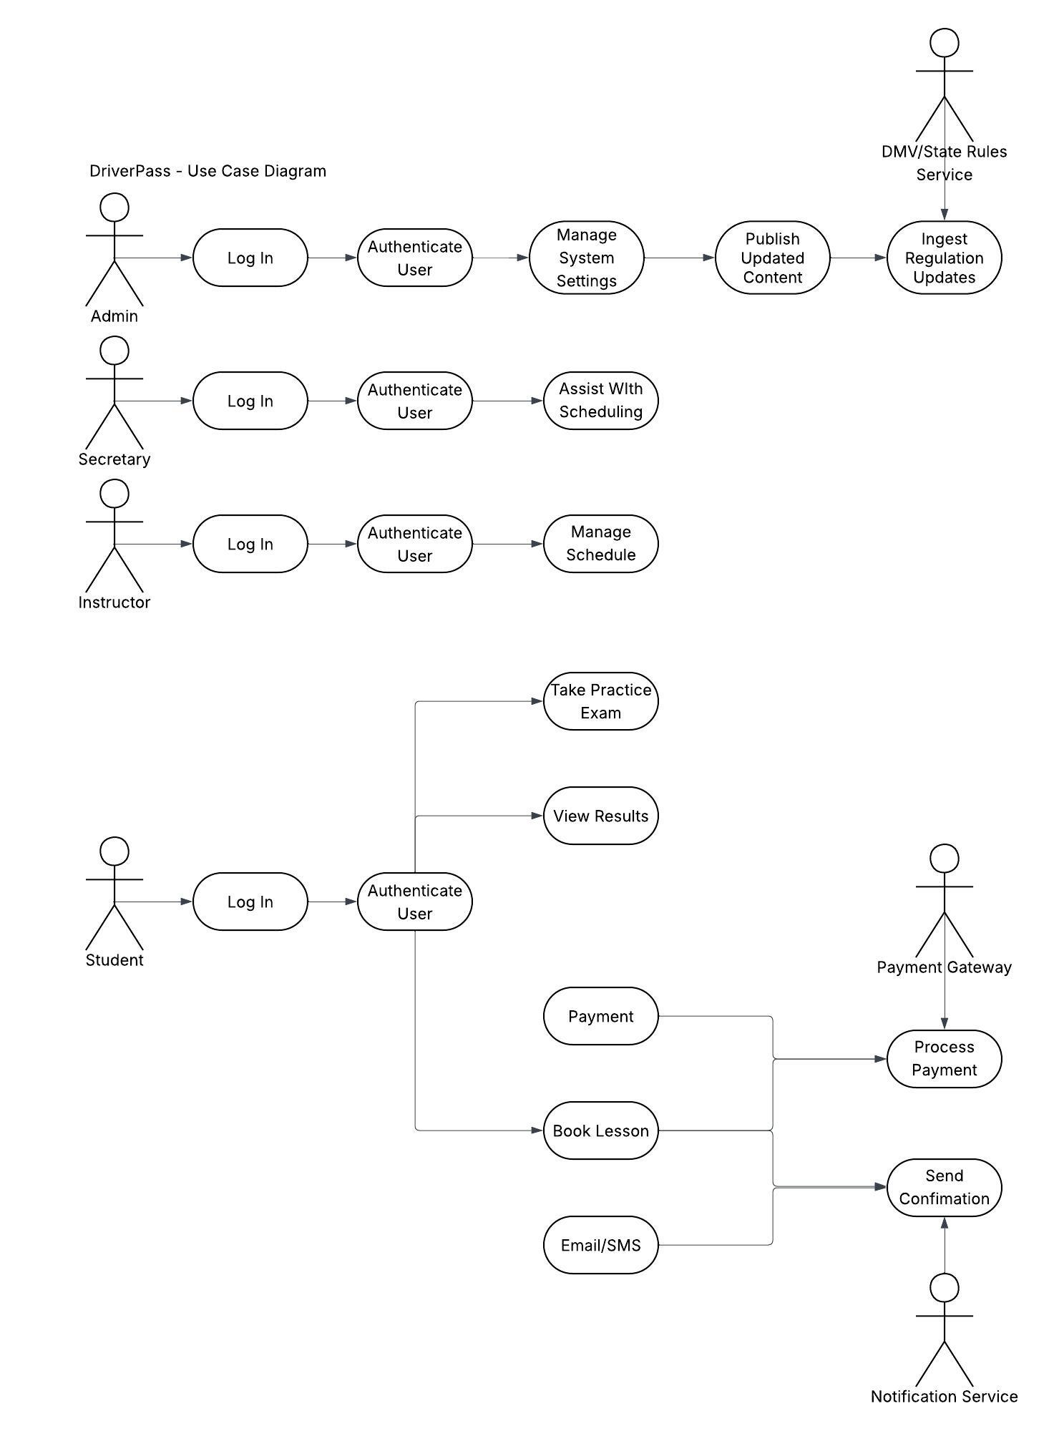

UML Activity Diagrams
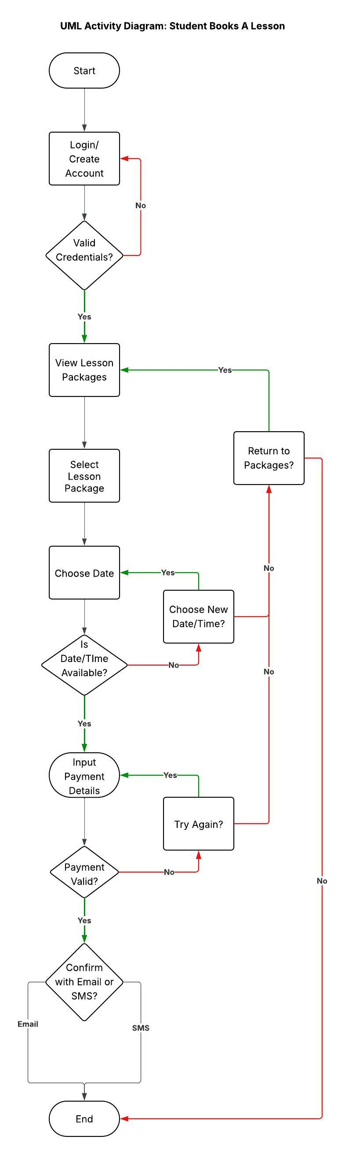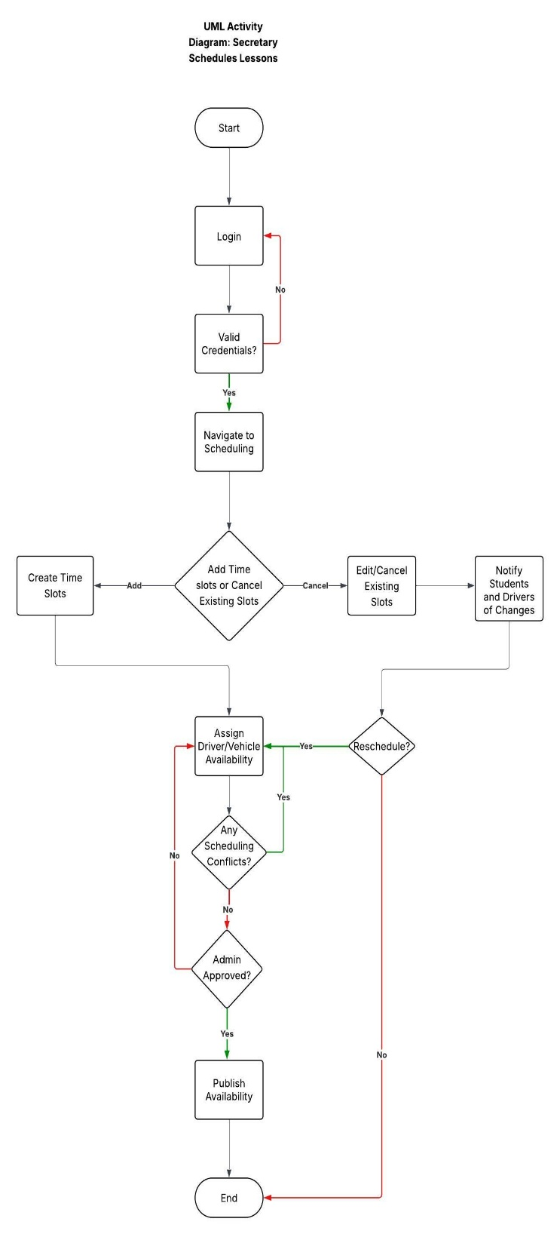

UML Sequence Diagram
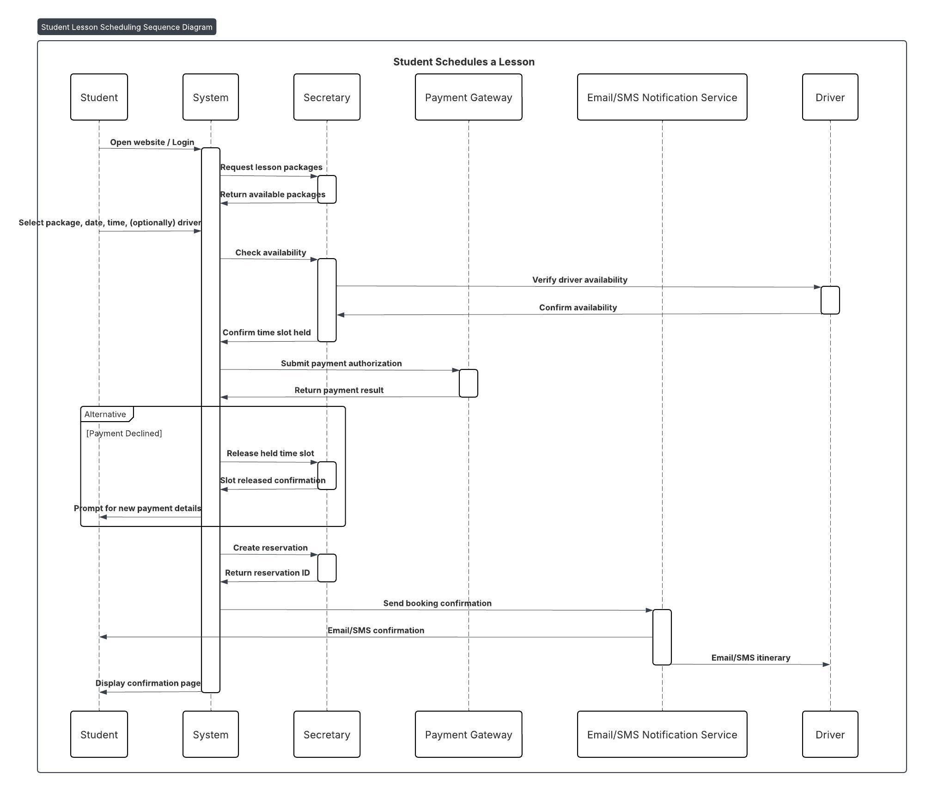

UML Class Diagram
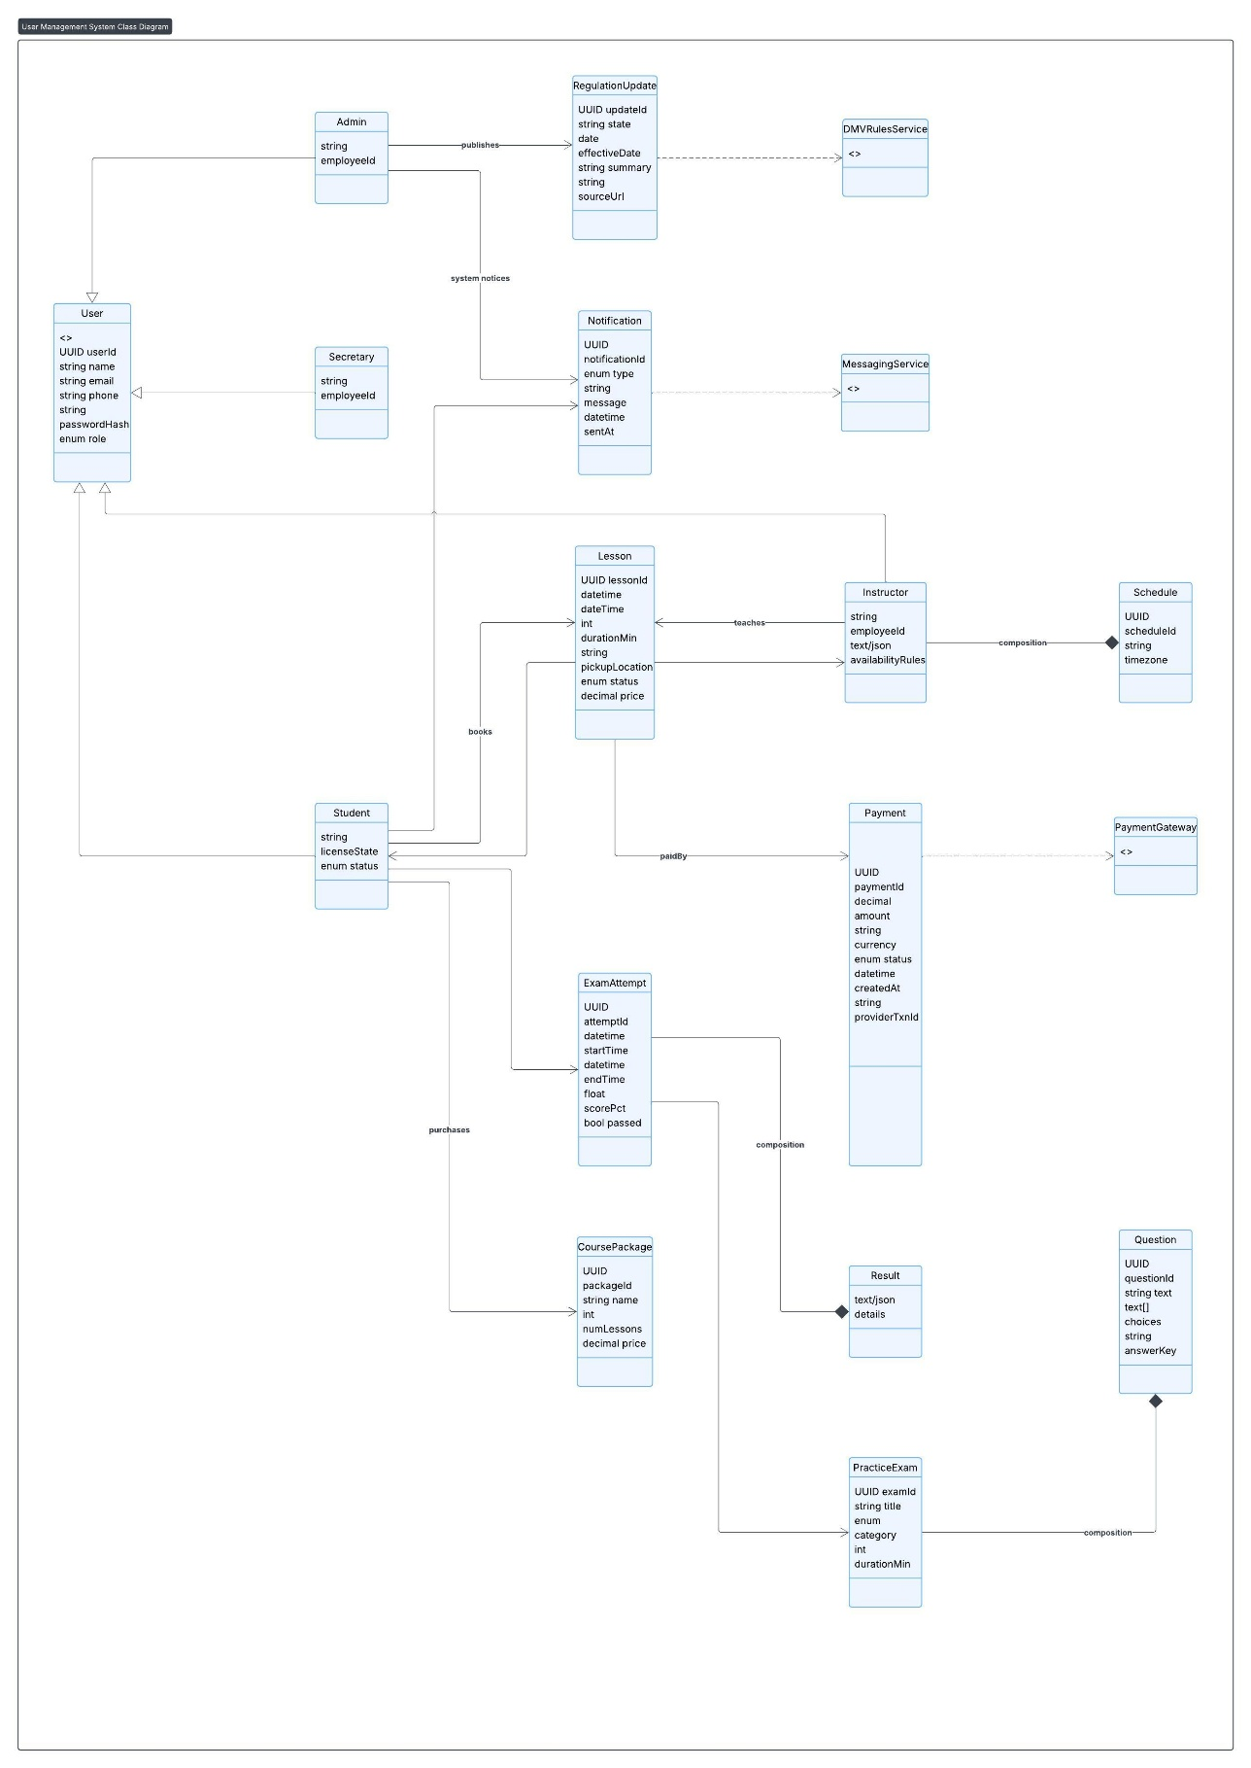

Technical Requirements
Functional Requirements
The functional requirements define the specific capabilities and behaviors the DriverPass system must deliver to meet user needs. These functions ensure the system provides a seamless and effective experience for students, administrators, and instructors.
- User Account Management: The system must allow users to create, manage, and authenticate accounts securely. Students should be able to register, log in, reset passwords, and update personal information.
- Online Practice Exams: Students must be able to take online practice driving tests that simulate real exam conditions. The system should automatically score responses, provide feedback, and store performance data for later review.
- Scheduling and Lesson Management: The platform must support booking, rescheduling, and canceling driving lessons. Instructors should be able to update availability, and students should receive real-time scheduling updates.
- Progress Tracking: Users must have access to progress dashboards showing completed lessons, test scores, and areas needing improvement.
- Administrative Tools: Administrators must be able to manage user accounts, monitor system performance, update test content, and generate reports on student performance and usage trends.
- Payment Processing: The system must include secure payment processing for lesson packages and exam fees, integrating with trusted payment gateways.
These features reflect the essential services DriverPass offers to prepare users for their driving exams and to streamline interactions between students, instructors, and administrators. Properly defining these functional elements helps ensure the system is user-centered and meets operational objectives (Sommerville, 2020).

Nonfunctional Requirements
Nonfunctional requirements specify the quality attributes and constraints that guide how the system should operate. While they do not define specific behaviors, they are essential for ensuring the platform’s reliability, usability, and long-term viability.
- Performance: The system should handle high traffic with minimal latency. Page load times should remain under three seconds, and the system should support at least 1,000 concurrent users without degradation in service quality.
- Platform Compatibility: DriverPass must function on major web browsers and mobile devices, ensuring accessibility across platforms. A responsive design is critical for users accessing lessons and tests on various screen sizes.
- Accuracy and Precision: Scoring algorithms for practice exams must be accurate, with minimal error margins, to reflect real-world exam expectations. Scheduling and data tracking must also maintain high precision to ensure trust and reliability.
- Adaptability: The system should be modular and scalable, allowing new features, such as additional training modules or analytics tools, to be added without significant redesign. Cloud-based architecture can support future expansion and integration with other systems (Pressman & Maxim, 2020).
- Security: Robust security measures must be implemented, including data encryption, two-factor authentication, and compliance with relevant data protection regulations. Regular security audits and vulnerability testing are essential for safeguarding sensitive user data (Pfleeger & Pfleeger, 2023).
- Usability: The interface should be intuitive and accessible to users with varying levels of technical expertise. Accessibility standards (e.g., WCAG 2.1) must be met to support users with disabilities.
- Reliability and Availability: The system should achieve at least 99.9% uptime and include automated backup and disaster recovery solutions. This ensures users can access training and scheduling tools without interruption.
These nonfunctional requirements enhance the system’s quality and long-term sustainability, ensuring that DriverPass is not only functional but also secure, efficient, and adaptable to evolving user needs (Pressman & Maxim, 2020).

References:
Pfleeger, C. P., & Pfleeger, S. L. (2023). Security in computing (6th ed.). Pearson.
Pressman, R. S., & Maxim, B. R. (2020). Software engineering: A practitioner’s approach (9th ed.). McGraw-Hill Education.
Sommerville, I. (2020). Software engineering (11th ed.). Pearson.

